Project report- Vlad Rotari & John Oladosu
Assign
Date
Status | Documentation
Type
Type 1
Type 3

Features that were implemented

Gradient Tool: Implemented a gradient tool allowing users to apply gradients to their drawings with customizable colours and directions.

Spray Can Tool: Developed a spray can tool enabling users to create a spray-painted effect on the canvas, with adjustable density and size.

Shapes Tool: Created a shapes tool providing predefined shapes (e.g., rectangles, circles, polygons) for users to insert into their drawings with customizable dimensions and styles.

Random Robot: Integrated a random robot feature generating unique robot designs to inspire users' creativity.

Cut, Copy, and Paste: Implemented basic editing functionalities allowing users to cut, copy, and paste elements within the canvas.

Set Color as Background: Enabled users to set a colour from the palette as the background colour of the canvas.

Brush Size: Incorporated a brush size feature allowing users to adjust the size of the drawing brush for finer or broader strokes.
- Custom slider examples include the spray can tool and shape tool.

How the project was planned and coordinated
The project commenced with discussions among team members regarding the approach to be taken. We decided to leverage the template of the drawing application provided in the case study as the foundation for our development. Regular meetups were held to discuss project aims, prioritise tasks, and determine the direction of the code. Communication primarily occurs through social media platforms such as WhatsApp, facilitating efficient collaboration and coordination. These weekly face-to-face meetups ensured that we held each other accountable when we were undertaking the project and the over-the-phone communication ensured that we were maintaining a consistent level of work at home apart from the meetups.
-See Appendices 1

How the code was structured

-See Appendices 2
The Drawing App project's code was carefully organised to promote simplicity and maintainability, utilising fundamental components from the original application architecture described in the case study. The basic architectural layout divided the drawing tools into their own toolbox.js module, which functioned as a central hub for controlling the several interactive tools, including the Gradient, Spray Can, Freehand, Line, and other specialised tools. Each tool was contained within its own JavaScript file (e.g., gradientTool.js, sprayCanTool.js), following the principles of single responsibility and modularity. With clearly defined interfaces, this method allowed each tool to function independently and seamlessly communicate with the main program. The architecture of the programme featured the tools as well as a specific helperFunctions.js script that had common functions like colour selection, brush size adjustment, and canvas event management that assisted the operations of the tools. The purpose of these assistance functions was to lessen repetition and increase the readability and effectiveness of the code. The development workflow was improved overall by making the codebase easier to navigate and update through the abstraction of common tasks. Additionally, adhering to current web development best practices, the use of HTML for the layout and CSS for styling ensured an individual allocation of responsibilities. This systematic approach facilitated better debugging and potential programme extensions in addition to simplifying the development process.

Coding techniques used
Techniques used for Scissor Tool
The scissor tool, considered one of the more complex tools, utilized a function-based approach for the precise selection and cutting of elements within the canvas. We used a function that serves as a constructor. Object-oriented Programming (OOP): The code defines a scissor Tool function that serves as a constructor for creating objects representing the tool. This approach encapsulates related data and functions within the object, promoting code organization and reusability.

DOM Manipulation: The scissor tool interacts with the Document Object Model (DOM) to create and manipulate HTML elements such as buttons, select dropdowns, and div containers. This is achieved using methods like document.getElementById, createButton, createSelect, and select (likely from the p5.js library).

Event Handling: The scissor tool sets up event listeners for various user interactions, such as mouse clicks and button presses, using functions like mousePressed and attaching event handlers to DOM elements.

Image Processing: The scissor tool enables selecting and manipulating areas within a canvas by capturing pixel data using the get function (likely from the p5.js library) and storing it in arrays. It also allows pasting selected areas back onto the canvas using the image function.

Data Structures: The scissor tool utilizes JavaScript objects and arrays to store and manipulate data, such as the selected area's coordinates, saved pixel data, and other tool settings.

Conditional Logic: The scissor tool employs extensive use of conditional statements (if, else, switch) to handle different tool modes and user interactions, ensuring appropriate actions are taken based on the current state and user input.

Function Abstraction: The scissor tool defines helper functions like getSelectedPixels, eraseSquare, hideButtons, and showButtons to encapsulate specific functionality and improve code readability and maintainability.

Variable Scoping: The scissor tool demonstrates an understanding of variable scoping by declaring variables within the appropriate scope (e.g., function scope, object properties) to control their accessibility and prevent naming conflicts.

Modular Design: The scissor tool is structured as a reusable module that can be integrated into a larger application or used in conjunction with other tools or modules.

The scissor tool includes basic error handling techniques, such as checking for null or empty input values, to prevent errors and provide user feedback.

Overall, the code showcases a variety of coding techniques commonly used in JavaScript programming, particularly in the context of web development and interactive canvas applications.

-Techniques used for Shape Tool
These tools employed specific coding techniques tailored to their functionalities, ensuring optimal performance and user experience.

-Techniques used for Gradient Tool
- See Appendices 3
The purpose of the Gradient Tool in my drawing application is to improve the artwork's visual appeal by producing a smooth transition between two or more colours. This application takes advantage of the HTML5 canvas API's linear gradient features, which enable the development of a gradual colour blend along a canvas-defined line. The basic procedure of the gradientTool.js script is to initialise a gradient object from the canvas context by calling the createLinearGradient () method. The gradient line's starting and ending coordinates must be defined to set the length and direction of the colour transition using this method.
The addColorStop() function is used in the logic of programming to add colour stops to the gradient object. Every colour stop has a specified colour and is positioned along the gradient line, which runs from 0 to 1, with 0 marking the gradient's start and 1 its finish. Gradients can be made complex and aesthetically pleasing by layering numerous colour stops together. Event listeners are linked to handle mouse events for user interaction, enabling users to click and drag across the required area of the canvas to dynamically set the gradient's start and end points. Because of its interactive design, which helps users achieve their chosen aesthetic by visually demonstrating the gradient effect in real time, the tool is both adaptable and intuitive.

-Techniques used for Spray Can Tool
The Spray Can Tool produces a scattered paint appearance on the canvas by imitating the action of a conventional spray paint can. To replicate the actual spray pattern of spray paint, this tool is created utilising a stochastic technique in which paint particles are randomly spread within a specific radius from the site of application. The fillRect() method is used in the sprayCanTool.js script to apply tiny dots to the canvas, which together produce the spray effect. To create the desired randomness, random offsets are generated for every dot within the predetermined radius. This prevents the dots from clustering too tightly, which would lead to an inaccurate representation of the spray paint effect.
The Spray Can Tool's programming methods include creating the x and y coordinates for each dot about the position of the mouse cursor using JavaScript's Math.random() function. The density parameter, which allows users to modify the number of iterations per frame, determines how many times this function is invoked within the loop. This option lets the user adjust the spray's density, which changes the tool's coverage and intensity. The tool also has an opacity parameter that lets users change the paint's transparency, which adds another level of intricacy. This function takes advantage of the canvas context's global alpha property, which establishes the opacity level for all ensuing drawings on the canvas until it is reset.
This feature increases the tool's versatility by allowing for more complex and textured effects that may be tailored to fit various creative requirements and tastes.

Challenges faced

Layering System Implementation: Despite attempts, integrating a layering system posed challenges due to compatibility issues with the existing code structure. Further development and refinement are required to address this limitation.

Deadline Management: Struggles with adhering to deadlines were encountered throughout the project timeline, necessitating improved time management strategies for future endeavours.

Issues found in testing

During testing, an issue was identified with the gradient tool's interaction with the canvas, resulting in inconsistent rendering of gradients. Efforts were directed towards troubleshooting and resolving this issue to ensure the tool's functionality meets user expectations.

Future Directions
- Enhanced Mobile Support: Optimizing the app for touchscreen interfaces to cater to mobile users.
- Expanded Tool Set: Adding more advanced tools such as a functional layering system which would allow users to switch between layers creating a more advanced drawing,
- User Accounts and Gallery: Introducing user account functionality to save, share, and view artworks in a community gallery.

Evaluation

Conclusion
In conclusion, the development of the drawing application has been a dynamic journey characterized by collaboration, challenges, and incremental progress. By leveraging existing resources and employing effective coding techniques, significant strides have been made towards realizing the project's objectives. Moving forward, continued refinement and enhancement of the application will be pursued to deliver a robust and user-friendly drawing tool. It would probably have been better to put the pencil size for the pencil next to the pencil but this didn’t seem like much of a functionality issue rather more an aesthetic issue.
Appendices
- 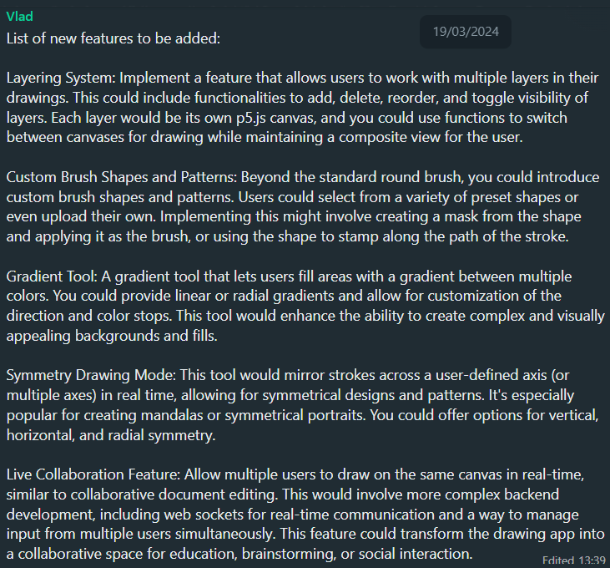
A WhatsApp message of potential features.
- 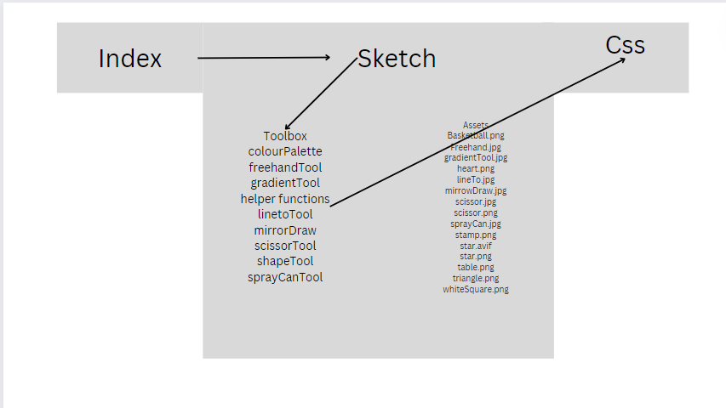

A diagram of the code’s structure
- 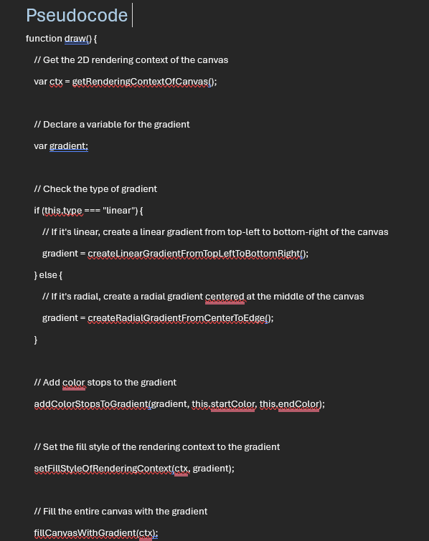
A screenshot of pseudocode of the Gradient Tool

